Trinity Lutheran Church
Box 118 Starbuck Manitoba R0G 2P0
204-735-2503
www.tlcstarbuck.com

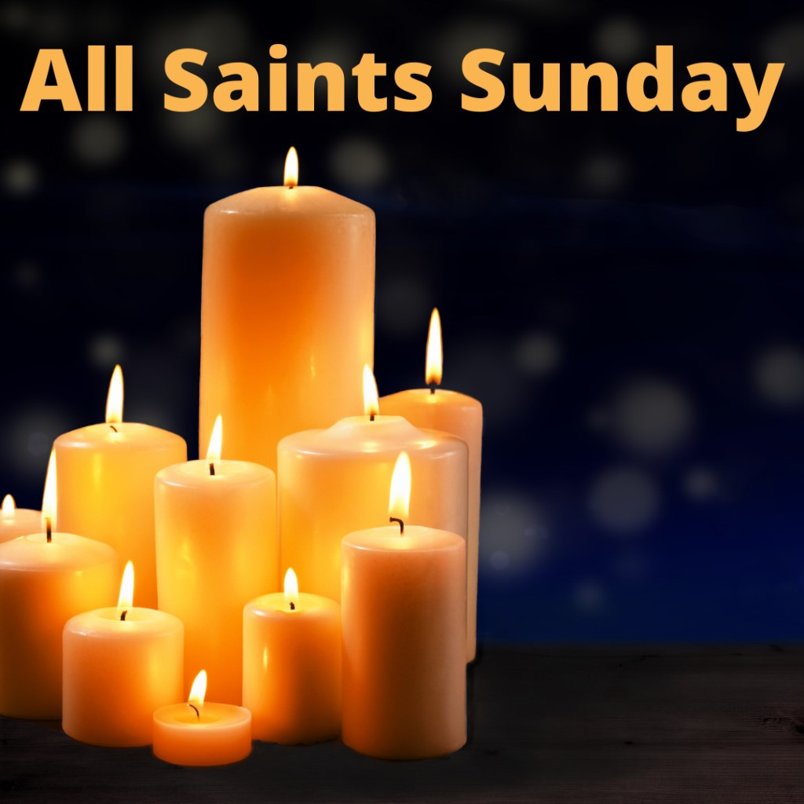

November 3, 2024
All Saints Sunday
ELW – Service of the Word
November 3, 2024

Prelude
Announcements

GATHERING
The Holy Spirit calls us together as the people of God.

Greeting
The grace of our Lord Jesus Christ, the love of God, and the communion of the Holy Spirit be with you all.
And also with you.

Gathering Song For All the Saints (Vs 1,2,5,6,7 are sung while candle cross is lit) ELW 422

Litany for All Saints
Today is all Saints Sunday; we remember the saints that have gone before us during this past year, the new saints that God has claimed through baptism, and all the saints throughout history and around the world. There is indeed a great cloud of witnesses.

In baptism God reaches down and claims us for sainthood. It is nothing that we do; it is all about God taking that first step. We cannot earn it. We do not deserve it. We cannot choose it. With the Word and in that very ordinary water, God chooses us and makes promises to us.

God promises to forgive our sins, to love us, to give us eternal life, and to move in, with and around that part of the Christian community that we call the body of Christ. Altogether, with all the Saints throughout history, with all the saints of today and with those saints who are still yet to come, we are all connected in the Kingdom of God. Even as we belong to God, we all belong to one another. Even though we are all different, in Christ we are given unity even within our diversity.

Let us give thanks to God for all the saints of our lives and the witness they share with us as we walk this journey of faith.

Let us pray. Eternal God, our help in ages past, our hope for years to come, we praise you for the saints of all times and places who have walked the road of faith before us and beside us. For their witness to your love and their commitment to your justice, for their trust in your mercy regardless of any circumstance, we give you thanks and praise.

God of all creation, we praise you for all your servants who have witnessed to your truth, who have shown us your love, who have inspired us to have hope. By their example of faith, hope, and love, remind us of our calling to join in making your new creation real in this world and in the world to come.

God of grace and peace, we praise you for women, men, children, and youth who have reflected your love in our world. Guide us to continue their faithful work, as we walk in the light of your love.

God of all saints, today we especially remember the saints from among us who have died or were buried during this past year. We thank you for the faithful witness of
Deaths (A bell will toll after each name is read)
Date of Death Date of Burial

Frances Pearl Lofto April 5, 2024 June 8, 2024
Christopher Edward Settee May 29, 2023 August 10, 2024
Dennis Olson October 30, 2023 September 14, 2024

For their courage amidst strife and their hope in the face of death.

We also remember so many other saints who have walked this road with us, whom we name before you aloud and in the silence of our hearts.
After a brief silence a single bell will toll

Family of God, we remember you, and we honour you. We know you are with us in the spirit of worship, and you will not be forgotten.

In Baptism our Creator God frees us from sin and death by joining us to the death and Resurrection of our Lord Jesus Christ. By water and the Holy Spirit we are reborn children of God and made members of the church, the body of Christ. Living with Christ and in the communion of saints, we grow in faith, love and obedience to the will of God.

We lift up to you, O God, the names of those whom you have entrusted to our care through birth and the Sacrament of Holy Baptism. May they grow in peace and strength and love.

Baptism (A bell will toll after the name is read)
Date of Baptism
Tate Matthew Donald Krysowaty July 21, 2024
Theodore James Carlson August 4, 2024

Birth (A bell will toll after the name is read)
Date of Birth
Laurel Elaine Surgenor August 17, 2024

Confirmation (A bell will toll after each name is read)
Date of Public Affirmation of Faith
Devin Mark Kendal May 19, 2024
Maxwell Gordon Nabess May 19, 2024
Jaxyn Rumer-Jean Thornson May 19, 2024

Prayer of the Day
Almighty God, you have knit your people together in one communion in the mystical body of your Son, Jesus Christ our Lord. Grant us grace to follow your blessed saints in lives of faith and commitment, and to know the inexpressible joys you have prepared for those who love you, through Jesus Christ, our Saviour and Lord, who lives and reigns with you and the Holy Spirit, one God, now and forever. Amen.

WORD
God speaks to us in scripture reading, preaching, and song.

First Reading Isaiah 25:6-9
Psalm Psalm 24
Second Reading Revelations 21:1-6a

Gospel Acclamation pg. 216

Alleluia. Lord, to whom shall we go? Alleluia. You have the words of eternal life. Alleluia, Alleluia.

Gospel Reading John 11:32-44
Children’s Chat
Sermon

Hymn of the Day Shall We Gather at the River ELW 423

The Apostles’ Creed pg. 217
Living together in trust and hope, we confess our faith.

I believe in God, the Father almighty,
creator of heaven and earth.
I believe in Jesus Christ, God’s only Son, our Lord,
who was conceived by the Holy Spirit,
born of the virgin Mary,
suffered under Pontius Pilate,
was crucified, died, and was buried;
he descended to the dead.
On the third day he rose again;
he ascended into heaven,
he is seated at the right hand of the Father,
and he will come to judge
the living and the dead.
I believe in the Holy Spirit,
the holy catholic church,
the communion of saints,
the forgiveness of sins,
the resurrection of the body,
and the life everlasting. Amen.

Prayers of Intercession
Let us turn our hearts to God, our breath and life, as we pray for the church, the world, and all who are in need.

Holy God, the church triumphant gathers around your throne to praise you. We join them in worship and remember your sustaining grace in every generation. Heal our divisions; show us unity in your presence. Lord, in your mercy, hear our prayer.

Holy creator, we marvel at your creation revealed in the cycle of seasons, changing landscapes, and the rise and fall of ocean tides. Turn us from selfish consumption and open us to the gentle healing of the earth so all creation thrives. Lord, in your mercy, hear our prayer.

Holy One, you raise up leaders to guide your people. Kindle in them a passion to care for others, a desire to seek the common good, and the courage to love their enemies. Lord, in your mercy, hear our prayer.
Holy healer, bless the broken-hearted and all who mourn. Send your compassion to all who grieve, grant wholeness to those who are sick, and accompany the dying. Be near to all who need you. We especially pray for those whom you have entrusted to our care. Lord in your mercy, hear our prayer.

Holy comforter, we pray for this congregation, that the promise of your new life may be shared and experienced. We pray for all those who are grieving the death of loved ones. May we as a congregation offer them tenderness and grace. Lord, in your mercy, hear our prayer.

Holy One, for the saints who now rest in your mercy, we give you thanks. We remember their witness of faithfulness and love. Praise to you for the eternal life they have been given through Jesus Christ. Lord, in your mercy, hear our prayer.

We offer our spoken prayers and those held in our hearts trusting in your mercy; through Jesus Christ our Saviour and Lord. Amen.

Sharing of the Peace
Jesus said to his disciples, ‘Peace I leave with you; my peace I give to you. I do not give it, as the world gives. Let not your hearts be troubled and neither let them be afraid.’ The peace of the Lord take hold of you, and those you love always.

THANKSGIVING
God hears the prayers of all to call out from the heart.

Offering
God of field and forest, sea and sky, you are the giver of all good things. Sustain us with these gifts of your creation, and multiply your graciousness in us, that the world may be fed with your love, through Jesus Christ, our Savior and Lord. Amen.

Canticle of Thanksgiving pg. 219
Salvation belongs to our God and to Christ the Lamb forever and ever.

Great and wonderful are your deeds, O God of the universe;
just and true are your ways, O Ruler of all the nations.
Who can fail to honor you, Lord, and sing the glory of your name?

Salvation belongs to our God and to Christ the Lamb forever and ever.

For you alone are the Holy One, and blessed is the one whose name is the Word of
God. All praise and thanks to you, holy God!

Salvation belongs to our God and to Christ the Lamb forever and ever.

Thanksgiving or the Word pg.220
O God of justice and love, we give thanks to you that you illumine our way through life with the words of your Son. Give us the light we need, awaken us to the needs of others, and at the end bring all the world to your feast; through Jesus Christ, our Savior and Lord, to whom, with you and the Holy Spirit, be honor and glory forever. Amen.

The Lord’s Prayer pg. 221

Our Father, who art in heaven,
hallowed be thy name,
thy kingdom come, thy will be done,
on earth as it is in heaven.
Give us this day our daily bread.
and forgive us our trespasses,
as we forgive those
who trespass against us
and lead us not into temptation,
but deliver us from evil.
For thine is the kingdom,
and the power, and the glory,
forever and ever. Amen.

SENDING
God blesses us and sends us in mission to the world.

Blessing
The Lord bless you and keep you.
The Lord’s face shine on you with grace and mercy.
The Lord look upon you with favor and ☩ give you peace. Amen.

Sending Song Ye Watchers and Ye Holy Ones ELW 424

Dismissal
Go forth into the world to serve God with gladness; be of good courage; hold fast to that which is good; render to no one evil for evil; strengthen the fainthearted; support the weak; help the afflicted; honor all people; love and serve God, rejoicing in the power of the Holy Spirit.

Now, go in peace, tell what God has done.
Thanks be to God.

The First Reading is from the book of the prophet Isaiah beginning at the 25th chapter and the 6th verse. (Isaiah 25:6-9)

6On this mountain the LORD of hosts will make for all peoples

a feast of rich food, a feast of well-aged wines,

of rich food filled with marrow, of well-aged wines strained clear.

7And he will destroy on this mountain

the shroud that is cast over all peoples,

the sheet that is spread over all nations;

8he will swallow up death forever.

Then the Lord GOD will wipe away the tears from all faces,

and the disgrace of his people he will take away from all the earth,

for the LORD has spoken.

9It will be said on that day,

Lo, this is our God; we have waited for him, so that he might save us.

This is the LORD for whom we have waited;

let us be glad and rejoice in his salvation.

Listen for the leading of the Spirit. Thanks be to God

Our Psalm is Psalm 24. We will say the Psalm responsively by whole verse. (Reader, please read all of the verses so that the people on line can hear the responses as well.)

1The earth is the LORD’s and all that is in it,

the world and those who dwell therein.

2For the LORD has founded it upon the seas

and established it upon the rivers.

3Who may ascend the mountain of the LORD,

and who may stand in God’s holy place?

4Those of innocent hands and purity of heart,

who do not swear on God’s being, nor do they pledge by what is false.

5They shall receive blessing from the LORD

and righteousness from the God of their salvation.

6Such is the generation of those who seek you, O LORD,

of those who seek your face, O God of Jacob.

7Lift up your heads, O gates; and be lifted up, O everlasting doors,

that the King of glory may come in.

8Who is this King of glory?

The LORD, strong and mighty, the LORD, mighty in battle!

9Lift up your heads, O gates; and be lifted up, O everlasting doors,

that the King of glory may come in.

10Who is this King of glory?

Truly, the LORD of hosts is the King of glory.

The Second Reading is from Revelations beginning at the 21st chapter and the 1st verse. (Revelations 21:1-6a)

1I saw a new heaven and a new earth; for the first heaven and the first earth had passed away, and the sea was no more. 2And I saw the holy city, the new Jerusalem, coming down out of heaven from God, prepared as a bride adorned for her husband. 3And I heard a loud voice from the throne saying,

“See, the home of God is among mortals.

He will dwell with them;

they will be his peoples,

and God himself will be with them;

4he will wipe every tear from their eyes.

Death will be no more;

mourning and crying and pain will be no more,

for the first things have passed away.”

5And the one who was seated on the throne said, “See, I am making all things new.” Also he said, “Write this, for these words are trustworthy and true.” 6aThen he said to me, “It is done! I am the Alpha and the Omega, the

Listen for the leading of the Spirit. Thanks be to God

The Holy Gospel according to John the 11th chapter (John 11:32-44)

Glory to You O Lord!

32When Mary came where Jesus was and saw him, she knelt at his feet and said to him, “Lord, if you had been here, my brother would not have died.” 33When Jesus saw her weeping, and the Jews who came with her also weeping, he was greatly disturbed in spirit and deeply moved. 34He said, “Where have you laid him?” They said to him, “Lord, come and see.” 35Jesus began to weep. 36So the Jews said, “See how he loved him!” 37But some of them said, “Could not he who opened the eyes of the blind man have kept this man from dying?”

38Then Jesus, again greatly disturbed, came to the tomb. It was a cave, and a stone was lying against it. 39Jesus said, “Take away the stone.” Martha, the sister of the dead man, said to him, “Lord, already there is a stench because he has been dead four days.” 40Jesus said to her, “Did I not tell you that if you believed, you would see the glory of God?” 41So they took away the stone. And Jesus looked upward and said, “Father, I thank you for having heard me. 42I knew that you always hear me, but I have said this for the sake of the crowd standing here, so that they may believe that you sent me.” 43When he had said this, he cried with a loud voice, “Lazarus, come out!” 44The dead man came out, his hands and feet bound with strips of cloth, and his face wrapped in a cloth. Jesus said to them, “Unbind him, and let him go.”

Praise to You O Christ!

