Youth:

Our October Youth event was a ton of fun! The youth enjoyed a Bible study, some snacks, and painted pumpkins.
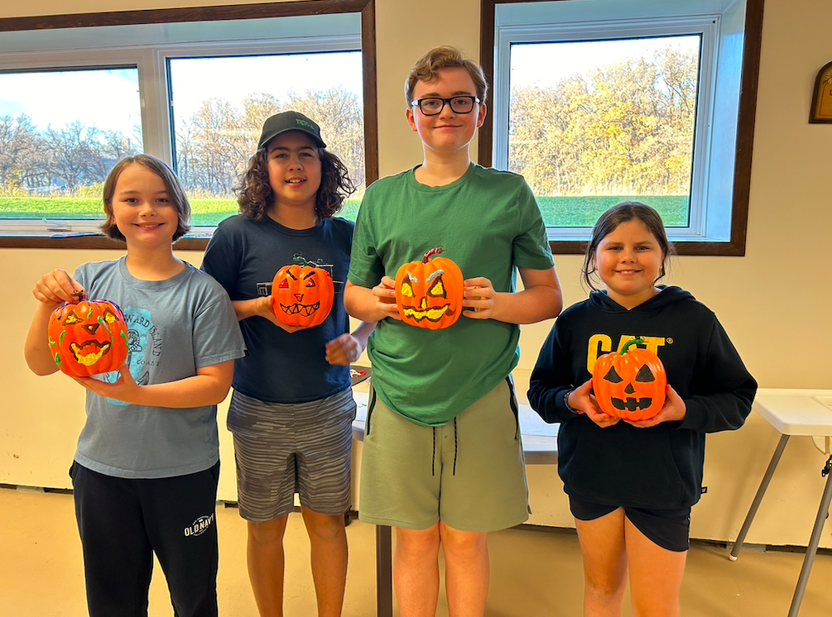
Our next youth event will take place on Sunday November 17th from 4-6pm. Keep an eye on your emails for further information!

-Brianna & Carrie

Starbuck History Book:

Plans are underway to create a Starbuck and District History Book, and we are establishing a committee to help with research, fundraising, and other related tasks. I’m excited to announce that Manitoba author Gordon Goldsborough will be heading up the writing and editing of this book!

We will be looking for pictures, anecdotes, and the histories of our businesses, clubs and institutions as well as family histories for residents past and present. We plan to include Starbuck, Ferndale, Prairie View and the “Starbuck Rink District.”
Please spread the word to others and let me know if you are interested in helping in any way. Thank you! Tammy Shirtliff 204-792-8170 or tshirtliff@gmail.com



A message from the Editor:

Hello everyone! If ever you have anything you would like included in upcoming newsletters, please email me at: briannahoude@gmail.com
Thank you! - Brianna

